# 5. Free Networks: We Are Only Just Beginning

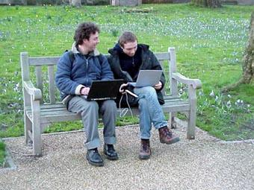Fig. 22 Gio and Alexi in the Wireless Spring.

We are only just beginning, is the message I have picked up from the two biggest communities in Europe, from Guifi.net and from Freifunk. Since the publication of the first chapter and this one, Guifi.net has grown from approximately 25,000 to 26,500 nodes. Similarly, the political implications of the free network movement have become more easily visible today. As Jürgen Neumann and Monic Meisel report, Freifunk has *unfortunately* benefited massively from the Snowden allegations. Since it has become known how massive the surveillance machinery is, self-managed networks suddenly make much more sense again. While many things have been coming together to make Freifunk possible, one thing was less in their favor, the German legal climate. Freifunk finds itself at the center of a prolonged battle about *Störerhaftung*.

In Germany, from the very start I was asked by potential node owners, if they would not get themselves into trouble by offering an unprotected WLAN access. In Germany, there was and is a big worry about so called Störerhaftung – liability for violations of laws by users of an open WLAN access point. In Germany, cases of legal precedence have been created, where owners of WLAN routers were held responsible for violations of law by people who had logged on to their access point and used it, for instance, for file sharing of copyright-protected music and films. Such cases, however, have been relatively rare. The real problem is that in Germany, there exist specialized law firms who have made it their business model to send threatening letters to people whom they accuse of a violation. While often there is hardly any evidence, and the intention of those law firms is not to take those cases actually to court, they offer people an easy way out by paying a certain sum for an out-of-court settlement. People unaware of their legal rights and maybe scared of entering a prolonged legal battle with an opponent they consider superior, give in and pay. This is a real nuisance and has created a situation of insecurity for participants in Freifunk. However, this is not the only threat to network freedom in Germany. There are genuine cases, where court cases have been brought by content providers and copyright owners who think their copyright has been infringed.

Freifunk has been battling those problems for a long time and has come up with some creative solutions. One is to build locally a community association which can then obtain the same status as a provider. While this solves the *Störerhaftung* problem it may create new ones such as costly legal obligations for data warehousing. So Freifunk in cooperation with the OpenWRT-Team released the first hundred *Freifunk-Freedom-Fighter-Boxes* – wireless routers flashed with an OpenWRT release configured to route all data via a virtual private network (VPN) through an ISP in Sweden, so that German law does not apply.

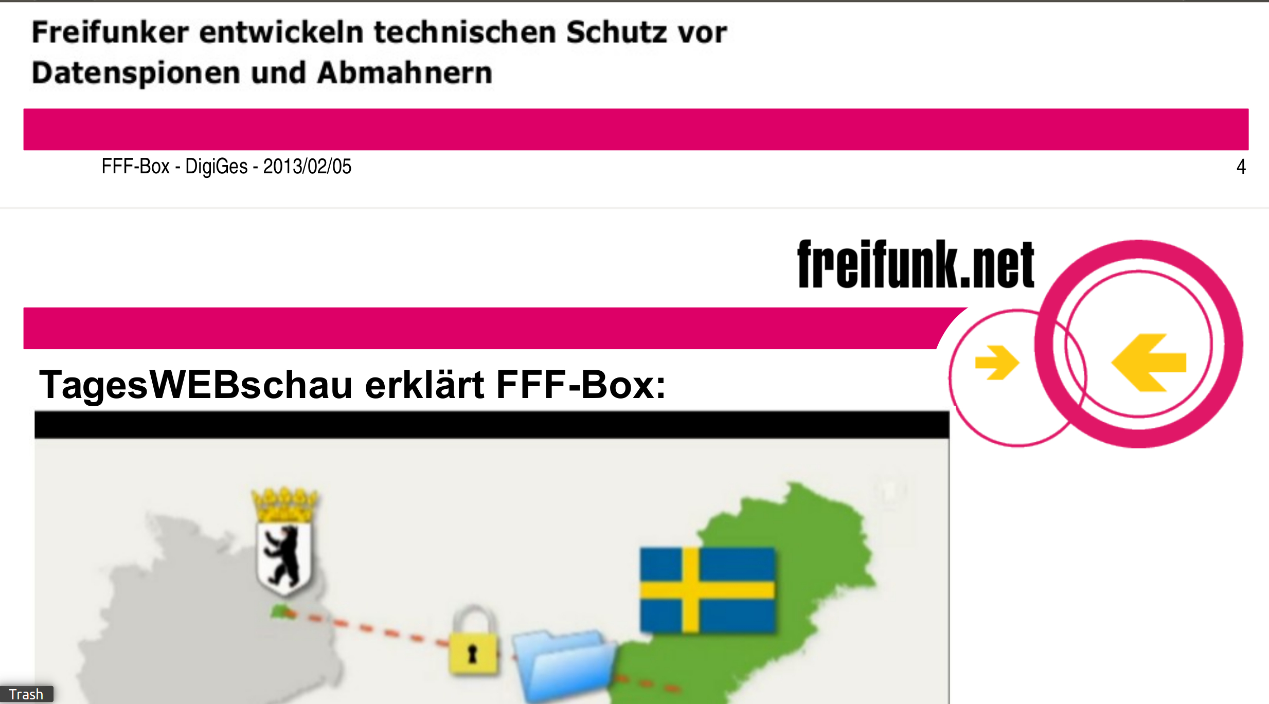Fig. 23. Freifunk Freedom Box on Mainstream TV.

This action, launched in 2012 under the title *Freifunk statt Angst* (Free radio instead of fear)[1]  
created plenty of publicity. In an initial action, Freifunk gave away one hundred Freifunk Freedom Fighter Boxes. When users logged on to such a router, they got a Splash page which informed them about the political background.[2] According to Jürgen Neumann, one of the founders of Freifunk, the action had always meant to be a temporary publicity stunt. However, the battle against *Störerhaftung* in Germany turned out to be quite a protracted one. And for many people it offered a relatively safe option.

At the same time, the Freifunk Freedom Fighter box was just one step of a larger counter-offensive on many layers. At the time of writing, in November 2014, there were several court cases going on concurrently. As Monic Meisel reported on 27 November 2014, one group of lawsuits had been stopped because the claimant had withdrawn all allegations. They obviously accepted that the accused was a member of Freifunk and that because of its quasi provider-like status there was no liability.[3] At the same time, the public climate also changed. In an article, Prof. Thomas Hoeren[4] reports that a number of court decisions had gone against *Störerhaftung*. Thomas Hoeren is a leading internet law expert in Germany and specialized in issues where technology and restrictions on it infringe on people’s civil liberties. According to Hoeren, the liability of node owners is not a foregone conclusion.

Störerhaftung has meanwhile become recognized as an impediment to the development of a creative information society in Germany. The number of open WLAN hotspots in proportion to the number of citizens in Germany is very low. As I can confirm as a frequent traveller, in many countries around the world, finding an open WLAN hotspot is quite easy, but not so in rich and bandwidth saturated Germany. German media, such as *Heute*, the news programme of public national television, have started to recognize that *Störerhaftung* is one of the main reasons why there are so few open WLAN hotspots in German cities, towns and villages.[5] The German coalition government has announced in its coalition agreement to enable open WLAN hotspots in German cities. A number of cities such as Hamburg now also want to realize this. But until *Störerhaftung* is revoked, there will be legal insecurity. A new draft law has been created which, it is claimed will provide legal security for node owners. But the devil is in the detail and this law is so badly drafted that it actually could achieve the opposite, argues Prof. Hoeren.[6]

Freifunk has started a campaign in 2014, which has intensified in 2015, asking its members to write to their MPs to not vote in favor of this law and demand significant changes.[7] Up until March 2015, more than 200 MPs received letters informing them about inefficiencies of this draft law. In my view, these are good steps but need to be intensified.

Wireless community networks are growing up, they are getting a political voice. In such cases the technology itself is not the center of attention but serves as a catalyst to ferment wider political action. The issues and hurdles posed to wireless community networking turn activists into educators of the public. Together with other activists working against surveillance and for open data, their activities raise issues that make the network more transparent for citizens. We can thus see different layers of being political.

On the most basic layer, material access is political, because there are situations and places where the availability of free or cheap broadband is an issue. We are reaching a point where not having internet seriously disadvantages you – you cannot fully participate in society. Freifunk Hamburg, for instance, in this podcast[8] tells about a refugee camp on the premises of St. Pauli church, where Freifunk Hamburg established a free hot-spot, without mightily banging its drum about it. Freifunk is now working with refugees in several cities, providing them with free internet, without advertising this too loudly, because of the many discriminations refugees face (not just in Germany).

While access to the network is one layer on which freedom can be formulated, another layer is the actual shape of the network. In the early 2000s, when free network movements started, broadband via ADSL and cable often came with restrictions, such as no fixed IP numbers and an automatic reset of the network connection once every 24 hours, as well as imbalance between upload and download speed. The actual shape of the network connection, its technical properties, also define how *free* a network is. This affects deep layers of network technology, where access points / providers have powers to filter and monitor traffic. Wireless community networks thus have an important function in educating the public but also politicians about the social necessity of net neutrality.

Finally, also on the layer of applications and content, networks can be more or less free. Here, one of the major sources of insecurity arises through issues such as copyright, or more generally speaking, intellectual property. In countries with a repressive regime, freedom of speech and other issues are also at stake. In my 2004 book *Freie Netze*[9] I tried to systematize those ideas by creating a layered model of network freedom. If demand arises, maybe I will translate and update this model.

In the meantime, however, since I wrote that earlier book, a major economic crisis has happened. Free network activists often appeared to rather robot-like repeat Richard Stallman’s dictum that the *free* in *free software* is not about free beer, but about free speech. Well, maybe this opinion turns out, if applied to networks, to be narrow and dogmatic. Free or at least cheap telecommunication is an important issue of our times. Especially after the outbreak of an economic crisis, even in the richest countries, there is a digital divide, as some groups or strata of society tend to have no internet or also no PCs. Such issues are often connected with intractable social problems, where issues of class, economics, gender, ethnicity, all come together.

This goes so far that a recent study in wealthy Austria concluded that 600,000 adult Austrians (out of a population of 8.5 million) are affected by functional illiteracy. Digital literacy is thus a major issue which has repercussions for many other areas which affect the basic life chances and citizen rights of people. This poses questions for self-serving views of some free network activists who think their networks are free because they use *free software*. When people have problems with reading and writing, the potentially *liberating* technology actually just creates further obstacles, as more basic problems need to be addressed first.

On the other hand, it is exactly the potential of the internet to create an open knowledge society that makes it still so attractive and which could also benefit disadvantaged people. In the following chapters, I will thus try to address those questions. On the one hand, the paradigm change from industrial to information society has remained incomplete. It has become stuck halfway, where older layers and mindsets prevail and prevent the full emancipatory potential of the Net to be realized (see next chapter The Incomplete Paradigm Shift). On the other hand, I am certainly not the first and only person to have recognized that there are complex relationships between free networks, free software and society. Those problems pose themselves in especially sharp focus when free networks are created in poor countries and rural areas.

1. Christian Heise, ‘Aktion gegen Störerhaftung: Anonym im WLAN an öffentlichen Plätzen mit Freifunk’, 14 June 2012, https://freifunkstattangst.de/2012/06/14/aktion-gegen-storerhaftung-anonym-im-wlan-an-offentlichen-platzen-mit-freifunk/.
2. Splash page of Freifunk WLAN Access Point, http://anon.freifunk.net/.
3. Monic Meisel, ‘Update zu den Feststellungsklagen’, 23 November 2014: http://freifunkstattangst.de/2014/11/23/update-zu-den-feststellungsklagen/.
4. Prof. Dr. Thomas Hoeren, *Schluss mit der Störerhaftung*, Süddeutsche Zeitung, 10 May 2015 https://www.sueddeutsche.de/digital/forum-wer-haftet-1.2473293.
5. Alfred Krüger, ‘Funkstille in deutschen Städten’, ZDF Heute, 25 November 2014, archived April 2015, https://web.archive.org/web/20150418235850/http://www.heute.de/freie-wlan-netze-funkstille-in-deutschen-staedten-rechtliches-problem-stoererhaftung-36042870.html.
6. Prof. Dr. Thomas Hoeren, *Schluss mit der Störerhaftung*, Süddeutsche Zeitung, 10 May 2015, https://www.sueddeutsche.de/wirtschaft/forum-wer-haftet-1.2473293.
7. Christian Heise, Gesetzesentwurf zur Neuregelung der Störerhaftung: Wie es jetzt weitergeht…, 13 March 2015, https://freifunkstattangst.de/2015/03/13/neuregelung-der-stoererhaftung-wie-es-jetzt-weitergeht/.
8. Hamburg.freifunk.net, podcast Freisprech 12, 06 November 2014, https://web.archive.org/web/20150317015328/https://hamburg.freifunk.net/2014/11/freisprech-12.html.
9. Armin Medosch, ‘Freie Netze. Geschichte, Politik und Kultur offener WLAN-Netze’, Heise Verlag, Hannover 2004, https://ftp.heise.de/tp/buch_11.pdf.